

**Clothing SHOP**

**A PROJECT REPORT**

SUBMITTED IN FULFILLMENT OF THE REQUIREMENT FOR THE AWARD OF THE DEGREE OF

**Bachelor of computer Application**

**TO**

**RK UNIVERSITY, RAJKOT**

**SUBMITTED BY**

**Name of Student Enrollment No.**

Nikunj Khunt 21FOTCA11072

Zezariya Darshan 21FOTCA11052

**UNDER THE GUIDANCE OF**

**Mr.Parvez Belim                                                                      Dr. Paresh Tanna**

RK University, Professor(HOD),

RAJKOT. RK University,

RAJKOT.



**SCHOOL OF ENGINEERING, RK UNIVERSITY,**

**RAJKOT**



**DECLARATION**

Your business description should include an overview of the products and services that your salon would offer, and how your salon would stand out in the market. Setting a trademark vibe to your salon also helps with its brand image.

This particular pre-feasibility is regarding HOSPITAL MANAGEMENT SYSTEM. The objective of the pre-feasibility report is primarily to facilitate potential entrepreneurs in project identification for investment and in order to serve his objective; the document covers various aspects of the project concept development, start-up, marketing, finance and management.

**Project Team**

Khunt Nikunj (22FOTCA11072)

Zezariya Darshan (22FOTCA11052)

**Date:**

**Place: -** Rajkot

**Table of contents**

|  |  |
| --- | --- |
| **TITLE** | **PAGE NO.** |
| ACKNOWLEDGEMENT | 4 |
| ABSTRACT | 5 |
| 1. INTRODUCTION | 6 |
| 1.1 ASP.NET | 7 |
| 2. PROJECT MANAGEMENT | 8 |
| 2.1 PROJECT PLANNING AND SCHEDULING | 8 |
| 3. SYSTEM REQUIREMENTS STUDY | 9 |
| 4. SYSTEM ANALYSIS | 10 |
| 4.1 FEASIBILITY STUDY | 10 |
| 4.1.1 E-R DIAGRAM | 11 |
| 4.1.2 USE CASE DIAGRAM | 12 |
| 4.1.3 DATA FLOW DIAGRAM | 13 |
| 5. DATABASE TABLE | 21 |
| 6. FLOW CHART | 23 |
| 7. ADMIN PANEL | 24 |
| 8. SCREEN SHOTS | 27 |
| 9. CONCLUSION AND DISCUSSION | 31 |
| 10. REFERENCES | 32 |

**ACKNOWLEDGEMENT**

The success and final outcome of this project required a lot of guidance and assistance from many people and We are extremely fortunate to have got this all along the completion of my project work.

Whatever we have done is only due to such guidance and assistance and we would not forget to thank them.

We respect and thank **RK University** for giving us an opportunity to do the project work in 6BCA and providing us all support and guidance which make us complete the project on time.

We are extremely grateful to him for providing such a nice support and guidance though he had busy schedule managing the company affairs.

We also thank our internal project guide, **Mr.Parvez Belim RK University Rajkot,** for his guidance and suggestions during this project work.

We are thankful to and fortunate enough to get constant encouragement, support and guidance from all Teaching staffs of Department of Bachelor of Computer Application which help Edu’s in successfully completing our project work.

Also, we would like to extend our sincere regards to all the non-teaching staff of department for their timely support.

**ABSTRACT**

**Shoe Shop Management System** is an organized computerized system designed and programmed to handle the day-to-day operations and management of a shoe retail store.

The purpose of the project “**Shoe Shop Management System**” is to digitalize the product and order management processes of the shop by developing software that is user-friendly, simple, fast, and cost-effective.

The main function of the system is to allow customers to browse and place orders for shoes, while administrators can manage product listings, track inventory, and process customer orders. The system stores product details, customer information, and order records, and retrieves or updates them as needed to ensure smooth operation.

Shoe Shop Management System follows an authentication-based model where only registered users and authorized admins can access the system’s features. The platform is built with data security and integrity in mind to protect user information and transaction history.

**1.INTRODUCTION:**

The project **Shoe Shop Management System** includes user registration, login functionality, product browsing, and order placement.  
The software assigns a unique ID to each product and stores the details of products, customers, and their orders in a secure and structured way.

The system is accessible through a secure login with a username and password.  
Customers can browse various shoe categories, view product details, and place orders.  
Admins can manage the product catalog, update stock, and view customer orders using their admin credentials.

Only authorized administrators can add or modify product and order data in the system.  
Stored information can be retrieved easily through simple navigation.

The interface is highly user-friendly, designed for smooth interaction and efficient management.  
**Shoe Shop Management System** is powerful, flexible, and easy to use—built to provide real and valuable benefits to shoe retailers and their customers.

* 1. **ASP.NET**

It is a web framework designed and developed by Microsoft.

It is used to develop websites, web applications and web services.

It provides fantastic integration of HTML, CSS and JavaScript.

It was first released in January 2002.

It is built on the Common Language Runtime (CLR) and allows programmers to write code using any supported .NET language.

ASP.NET is a part of Microsoft .NET Framework.

**2.PROJECT MANAGEMENT**

**2.1 PROJECT PLANNING**

Project planning is one of the essential tasks carried out during the development of the Shoe Shop Management System. Through project planning, the overall scope, size, time, and cost of the system were estimated accurately to ensure smooth development.

Planning for this system began with a clear understanding of the project definition. An upper-level analysis was first performed to grasp the entire structure of the system. This analysis helped in identifying the key modules, their interconnections, and the data flow, which formed the basis for developing a detailed and efficient project plan.

**PROJECT SCHEDULING**

The project work plan outlines all the key activities required to complete the system and estimates the time needed for each task. The scheduled workflow for this system progressed as follows:

1. Initial Analysis:  
   The project concept and problem domain were thoroughly analyzed before any development work began.
2. Requirement Gathering:  
   Requirements were gathered by studying similar e-commerce and inventory systems. All essential features and functionalities were collected to design a modern and efficient shoe shop platform.
3. System Design:  
   The user interface and system architecture were designed in parallel to ensure both front-end usability and back-end integrity.
4. Implementation:  
   The development phase included coding modules for login, product management, order tracking, and customer handling.
5. Parallel Tasks:  
   Activities such as designing, coding, system analysis, and requirement validation were executed in parallel to optimize the timeline and ensure consistency across the system.

**3. SYSTEM REQUIREMENTS STUDY**

Visual Studio 2019 is a complete set of development tools for building

• ASP Web applications

• XML Web services

Desktop applications

mobile applications

Visual Basic .NET, Visual C++ .NET, and Visual C# .NET all use the same integrated development environment (IDE), which allows them to share tools and facilitates in the creation of mixed-language solutions.

Visual C#, pronounced C sharp, is a new object-oriented programming language that is an evolution of C and C++, providing a simple and type-safe language for developing applications.

The .NET Framework is a new computing platform that simplifies application development in the highly distributed environment of the Internet. The .NET Framework is designed to fulfil the following objectives:

To provide a consistent object-oriented programming environment whether object code is stored and executed locally, executed locally but Internet-distributed, or executed remotely.

To provide a code-execution environment that minimizes software deployment and versioning conflicts.

**4. SYSTEM ANALYSIS**

**4.1FEASIBILITY STUDY:**

**Scope of the Study:**  
The overall scope of the feasibility study was to evaluate the viability of implementing a Shoe Shop Management System (SSMS) and determine whether the project should proceed. It will also assess the relative priority of this system compared to existing systems in use (such as inventory management or sales tracking systems).

**4.1.1 ER-DIAGRAM**

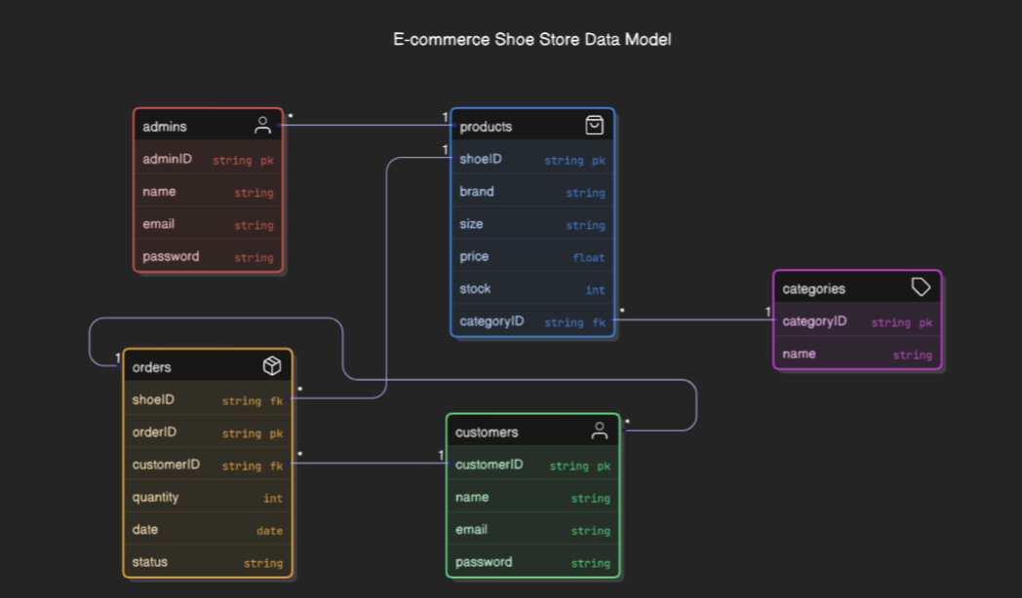

Fig: 4.1.1 ER Diagram

**4.1.2 USE CASE DIAGRAM**

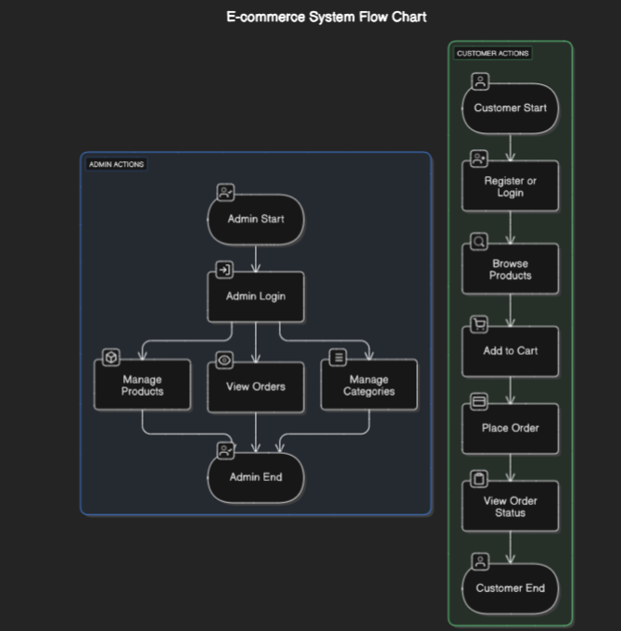

Fig: 4.1.2 Use Case Diagram

**4.1.3 DATA FLOW DIAGRAM**

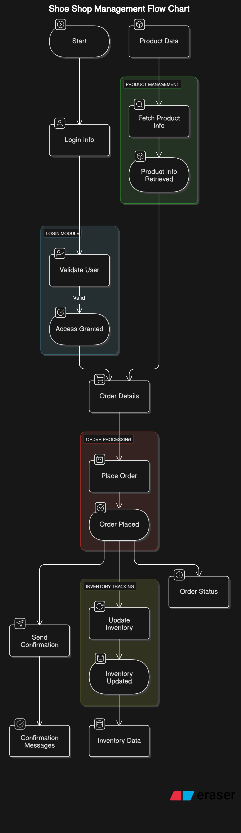

Fig: 4.1.3.1 Context Level DFD

**5.DATABASE TABLE:**

**Admin Table:-**

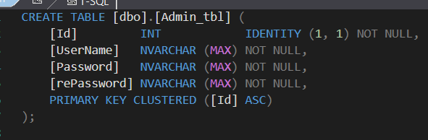

**Creat table:-**

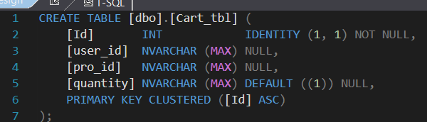

**Category tbl:-**

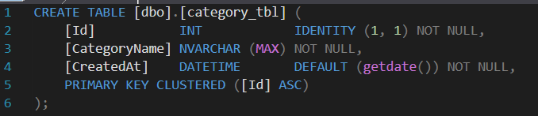

**Product tbl:-**

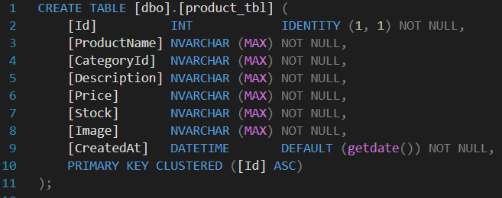

**Product tbl:-**

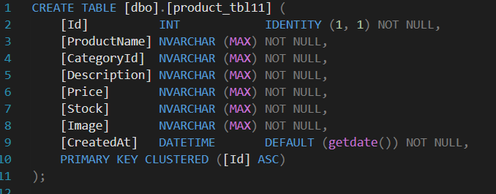

**Table_Users**

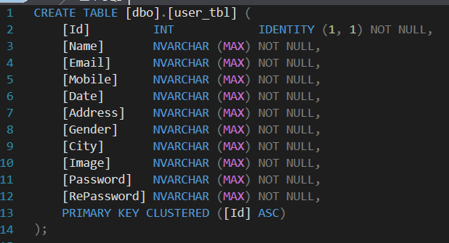

**Register Page:-**

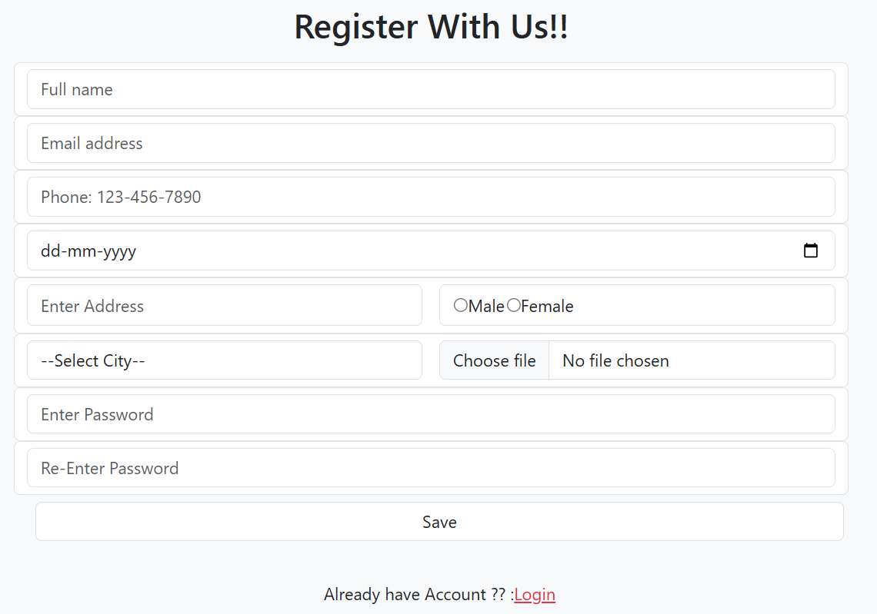

Login :-

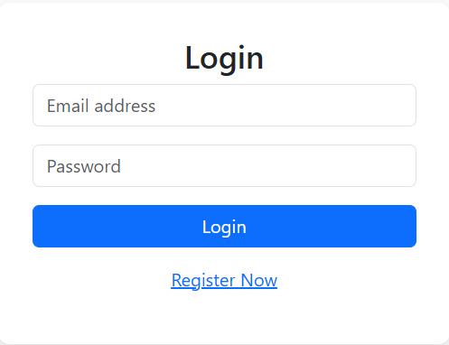

**Contact Details**

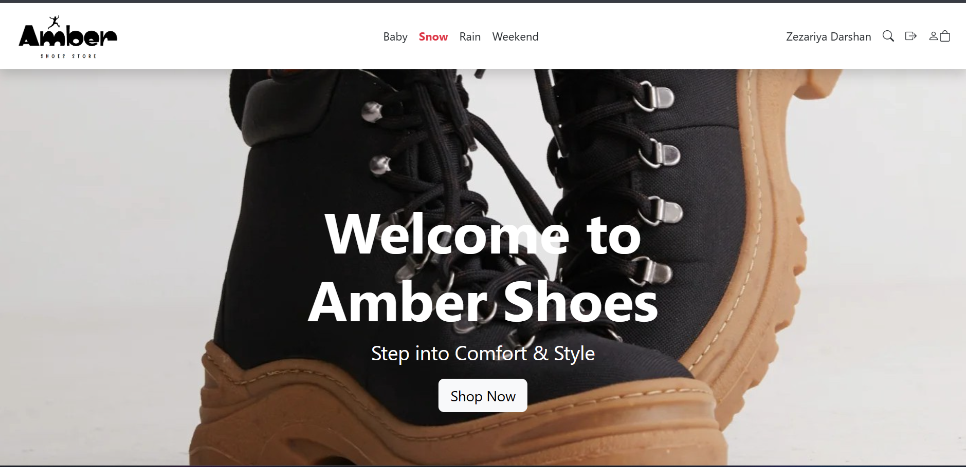

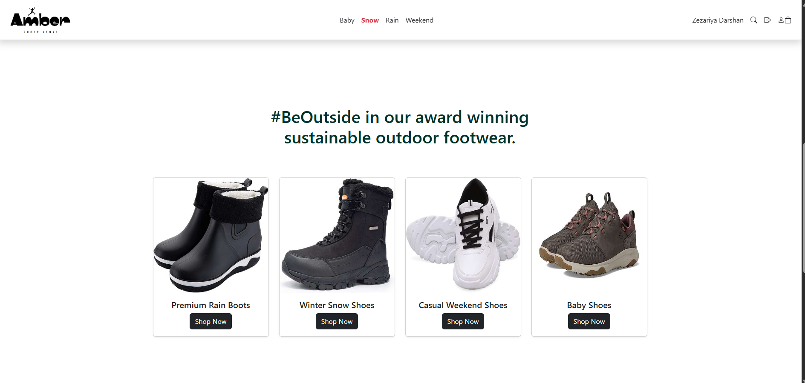

**Rain Details**

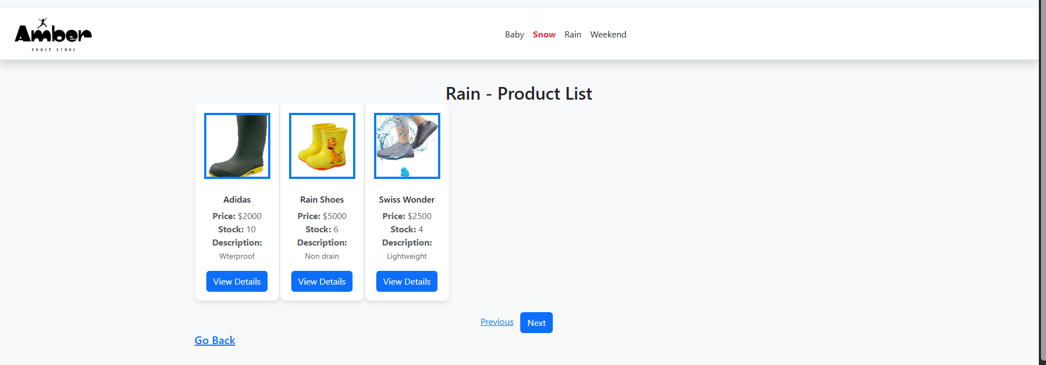

**Snoe Category:**

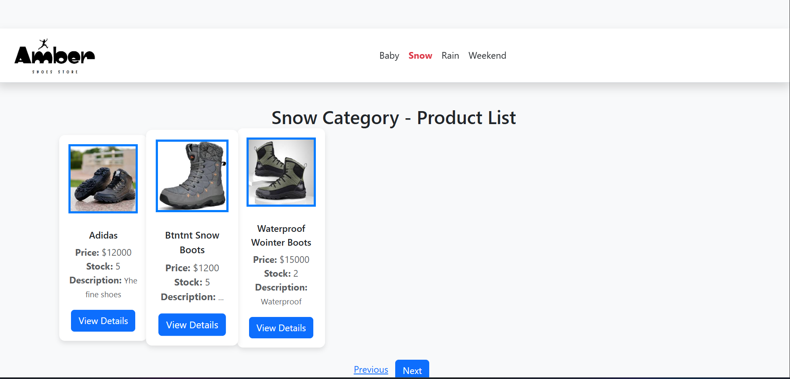

**View Detail:-**

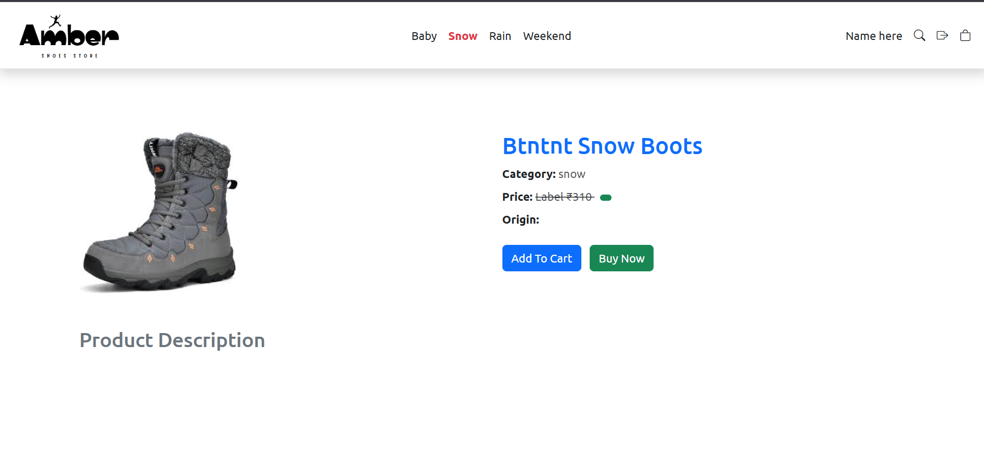

**Add To Cart:-**

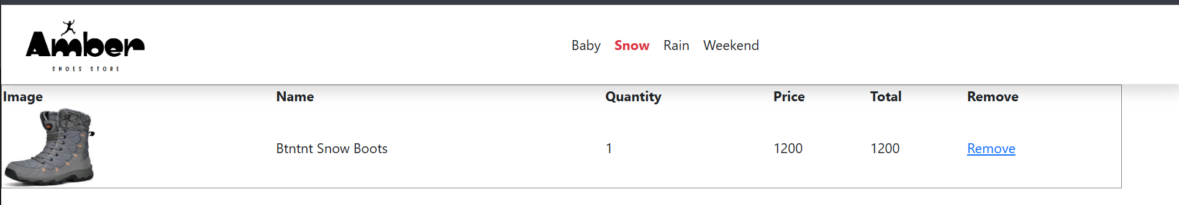

**Profile:-**

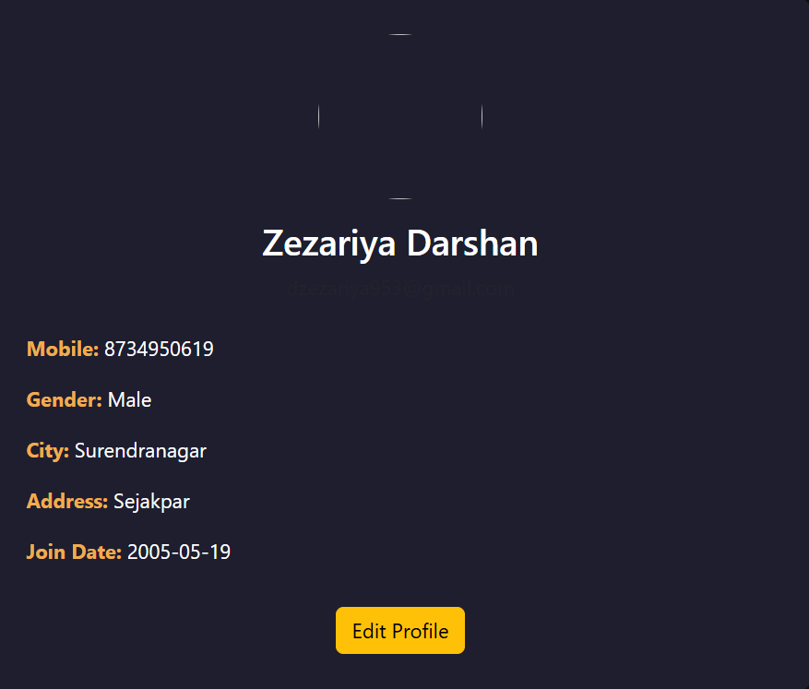

**7.ADMIN PANEL :-**

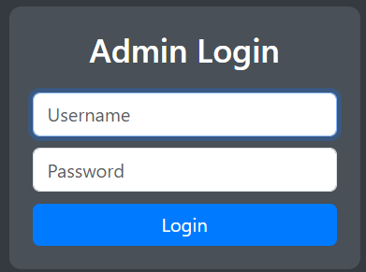

**Admin Panel:-**

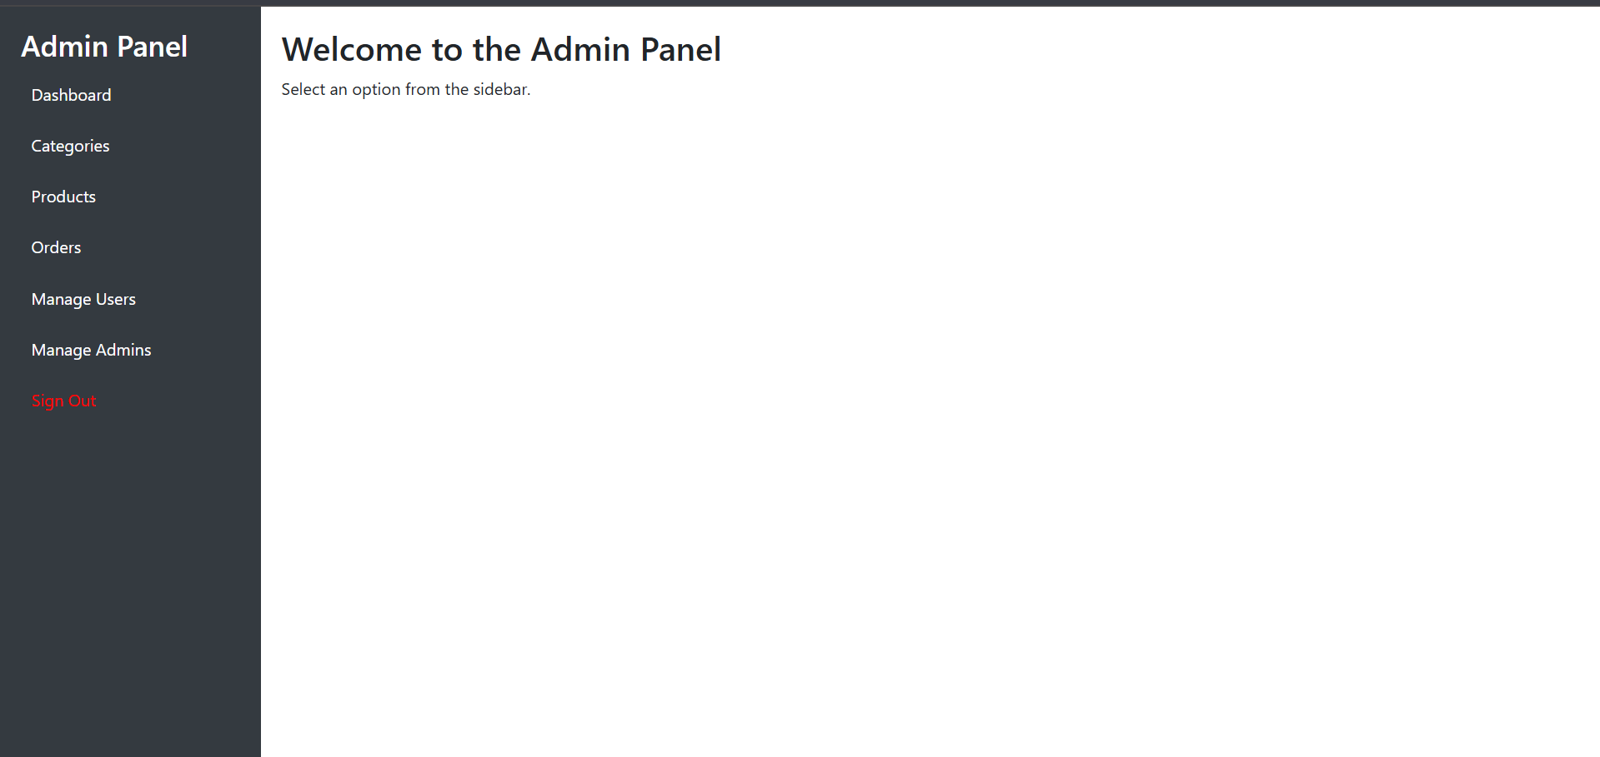

**Dashboard:-**

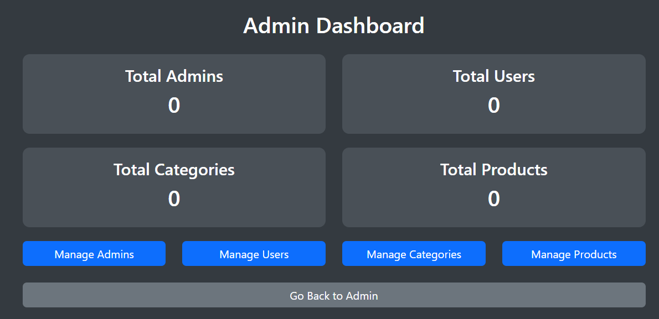

**Add Category:-**

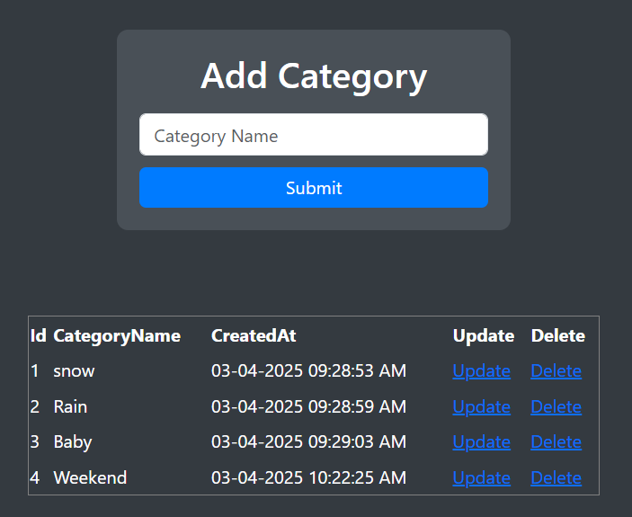

**Add New Product:-**

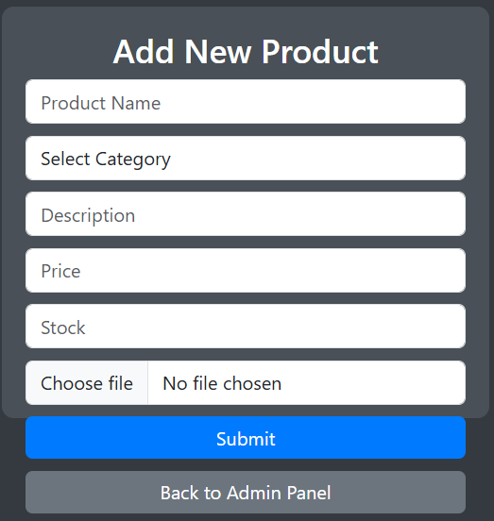

**New Admin Add:-**

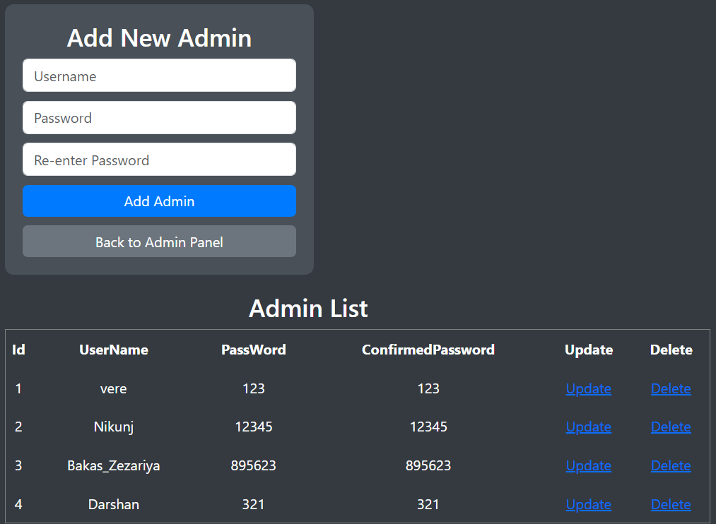

**9. CONCLUSION AND DISCUSSION**

The demand for efficient and automated solutions in retail management has been growing steadily, driven by the ever-increasing expectations of both businesses and customers. In this context, developing a **Shoe Shop Management System (SSMS)** became an important step in enhancing business operations and streamlining store management processes.

Automating an office application like the SSMS not only provided practical solutions to real-world business problems but also expanded our knowledge in the field of system development. The project highlighted the importance of organizing complex tasks into smaller, more manageable units, which aligned perfectly with the **Software Development Life Cycle (SDLC)** model. This approach helped in the systematic design, development, and testing of the system, ensuring that each stage was thoroughly addressed.

Furthermore, the development of the SSMS reinforced the analytical mindset required to solve complex problems effectively. It allowed us to better understand the intricacies of real-time data management, user interaction, and system integration, ultimately leading to a more user-friendly and efficient software solution.

Indeed, the experience of automating the Shoe Shop management system was a valuable learning opportunity, strengthening our skills in software engineering, project management, and client-oriented development.

**10.REFERENCES**

* [www.asp.net](https://www.asp.net)
* [www.tutorialspoint.com/asp.net/](https://www.tutorialspoint.com/asp.net/)
* [www.google.com](https://www.google.com)
* [www.slideshare.com](https://www.slideshare.com)
* [ChatGPT](https://chat.openai.com)